Radio Broadcasting Registration Form
Studio contact: 01422 400 180
eMail: huddssocaradiotv@outlook.com

Personal Details
Name
…………………………………………………………………………….........................................................
Home Address
…………………………………………………………………………….........................................................
Date of birth
…………………………………………………………………………….........................................................
Contact Tel
…………………………………………………………………………….........................................................
Contact Email Address
…………………………………………………………………………….........................................................
Do you have any criminal convictions? If so, what for and when?
…………………………………………………………………………….........................................................

Radio Broadcasting Experience (If you have none, please still apply)
Have you played on a Soca or calypso stage? If so, when and which stage?
…………………………………………………………………………….........................................................
Have you broadcast for other stations? If so, when, which station and music genre?
…………………………………………………………………………….........................................................
Have you worked as a carnival float DJ or similar? If so, when and where?
…………………………………………………………………………….........................................................

Do you have experience as a club DJ? If so, when, where and which music genre?
…………………………………………………………………………….........................................................
How many hours per week you can volunteer?
…………………………………………………………………………….........................................................

Application Requirements
A copy photo ID (passport/ DVLC), utility bill and DBS check is required with all applications
…………………………………………………………………………….........................................................
Signature Date
…………………………………………………………………………….........................................................
Print name
…………………………………………………………………………….........................................................
Thank you, for your application.

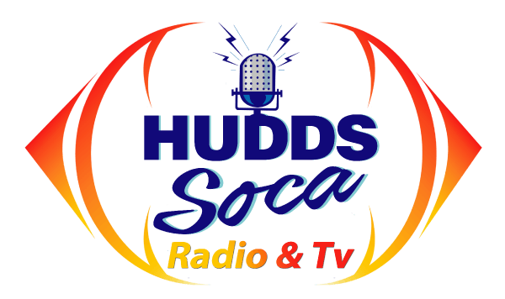

- Powered by -
Hudds Soca Radio & TV

